Multiclass Prediction

**SoftMax Regression, One-vs-All & One-vs-One for Multi-class Classification**

In Multi-class classification, we classify data into multiple class labels. Unlike classification trees and nearest neighbors, the concept of Multi-class classification for linear classifiers is not as straightforward. We can convert logistic regression to Multi-class classification using multinomial logistic regression or SoftMax regression; this is a generalization of logistic regression. SoftMax regression will not work for Support Vector Machines (SVM); One vs. All (One-vs-Rest) and One vs One are two other multi-class classification techniques that can convert most two-class classifiers to a multi-class classifier.

# SoftMax Regression

SoftMax regression is similar to logistic regression, the SoftMax function converts the actual distances i.e. dot products of 𝑥 with each of the parameters $θ_{i}$ ​ for 𝐾 classes in the range from 0 to 𝐾-1. This is converted to probabilities using the following formula.

$$softmax\left(x, i\right)=\frac{e^{{-θ}_{i}^{T}x}}{\sum_{j=1}^{K}{e^{{-θ}_{i}^{T}x}}}(1)$$

The training procedure is almost identical to logistic regression using cross-entropy, but the prediction is different. Consider the three-class example where y $∈\{0,1,2\}$ i.e y can equal 0,1,2. We would like to classify x. We can use the SoftMax function to generate a probability of how likely the sample belongs to each class. We then make a prediction using the $argmax$ function:

$$\hat{y}=argmax_{i}\left(softmax\left(x,y\right)\right)(2)$$

Let’s do an example, consider sample $x_{i}$ we will start by creating a table where each column will be the $i-th$ values of the SoftMax function. The index of each column is the same as the class.

|  |  |  |
| --- | --- | --- |
| $$probability of \hat{y}=0$$ | $$probability of \hat{y}=1$$ | $$probability of \hat{y}=2$$ |
| $$softmax\left(x_{i}, 0\right)$$ | $$softmax\left(x_{i}, 1\right)$$ | $$softmax\left(x_{i}, 2\right)$$ |
| $$i=0$$ | $$i=1$$ | $$i=2$$ |

**Table 1. Each column will be the i-th values of the SoftMax function. The index of each column is the same as the class.**

Let’s add some real probabilities, this is the models estimate of how likely a sample belongs to each class.

|  |  |  |
| --- | --- | --- |
| **0.97** | **0.02** | **0.01** |
| $$i=0$$ | $$i=1$$ | $$i=2$$ |

**Table 2. Table of real probabilities. Each column will be the i-th values of the SoftMax function. The index of each column Is the same as the class.**

We can represent the probability as a vector [0.97,0,02,0.01]. To get the class we simply apply the *argmax* function, this returns the index of the largest value.

$$\hat{y}=argmax_{i}\left(\left[0.97, 0.02,0.01\right]\right)$$

$$\hat{y}=0$$

**Geometric Interpretation**

Each $θ_{i}^{T}x$ is the equation of a hyperplane, we plot the intersection of the three hyperplanes with 0 in fig 1 as colored lines, in addition, we can overlay several training samples. We also shade the regions where the value of $θ_{i}^{T}x$ is largest, this algo corresponds to the largest probability. This color corresponds to where a sample x would be classified. For example if the input is in the blue region, the sample would be classified $\hat{y}=0$, if the input is in the red region it would be classified as $\hat{y}=1$, and in the yellow region $\hat{y}=2$. We will use this convention going forward.

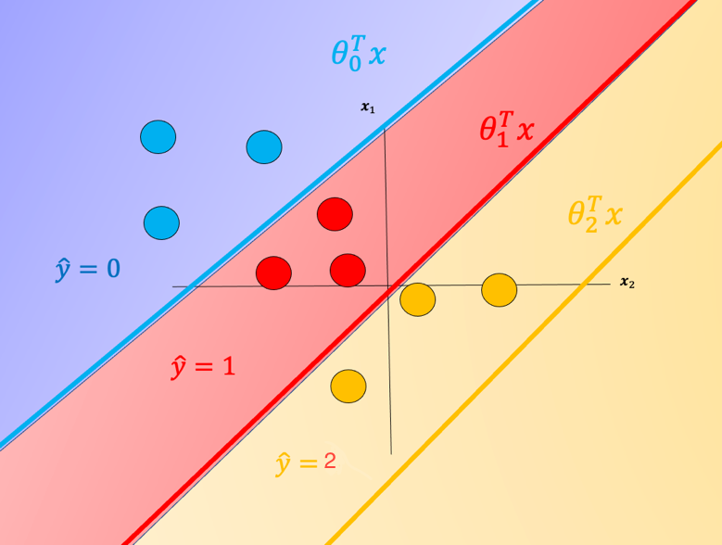

#### **Fig 1. Equation of a hyperplane. We plot the intersection of the three hyperplanes with 0, in addition we can overlay several samples.  We also shade the regions where the value of i is largest.**

One problem with SoftMax regression with cross-entropy is it cannot be used for SVM and other types of two-class classifiers.